CONCEPT MAPPING

Q1: A banking system performs operations such as deposits, withdrawals, and transaction tracking. Construct a concept map connecting ADT → Operations → Interface → Implementation → Data Structures.

#include <stdio.h>

int balance = 1000;

void deposit(int amt) { balance += amt; }
void withdraw(int amt) {
if (amt <= balance) balance -= amt;
else printf("Insufficient Balance\n");
}

int main() {
deposit(500);
withdraw(200);
printf("Balance: %d", balance);
}
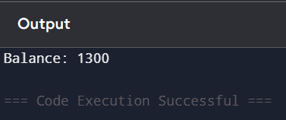

Q2: A file system contains nested folders and files organized hierarchically. Construct a concept map linking Recursion → Base Case → Recursive Case → Call Stack → Function Calls → Memory Usage.

#include <stdio.h>

int fact(int n) {
if (n == 0) return 1;
return n * fact(n - 1);
}

int main() {
printf("%d", fact(5));
}
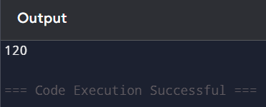

Q3: A program processes complex nested data structures and requires efficient computation. Construct a concept map connecting Recursion → Call Stack → Memory Usage → Iteration → Loop Control → Efficiency.

#include <stdio.h>

int recSum(int n){
if(n==0) return 0;
return n + recSum(n-1);
}

int main(){
int i,sum=0;
for(i=1;i<=5;i++) sum+=i;
printf("Iteration: %d\n", sum);
printf("Recursion: %d", recSum(5));
}
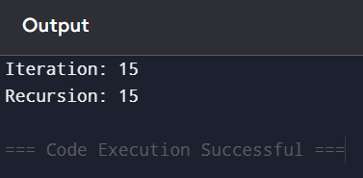

Q4: A music streaming application manages playlists where songs are added, removed, and played sequentially. Construct a concept map linking Array → Linked List → Stack → Queue → Operations.
#include <stdio.h>
#include <stdlib.h>

struct Node {
int song;
struct Node *next;
};

int main() {
struct Node *head = NULL, *newNode;
newNode = (struct Node*)malloc(sizeof(struct Node));
newNode->song = 1;
newNode->next = NULL;
head = newNode;

printf("Song added: %d", head->song);
}
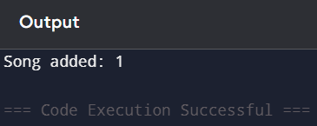

Q5: A social media platform represents users and their connections in a network. Construct a concept map connecting Tree → Hierarchical Data → Graph → Network Data → Traversal (DFS/BFS).
#include <stdio.h>

int graph[5][5], visited[5];

void dfs(int v){
printf("%d ", v);
visited[v]=1;
for(int i=0;i<5;i++){
if(graph[v][i] && !visited[i])
dfs(i);
}
}

int main(){
graph[0][1]=graph[1][2]=1;
dfs(0);
}
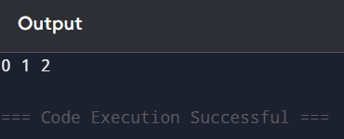

Q6: A system needs to search for specific records in a large dataset efficiently. Construct a concept map linking Searching Algorithm → Linear Search → Binary Search → Time Complexity → Efficiency.
#include <stdio.h>

int main(){
int a[5]={1,2,3,4,5}, key=3, i;

// Linear Search
for(i=0;i<5;i++){
if(a[i]==key) printf("Found at %d\n", i);
}

// Binary Search
int l=0,h=4,mid;
while(l<=h){
mid=(l+h)/2;
if(a[mid]==key) break;
else if(key>a[mid]) l=mid+1;
else h=mid-1;
}
printf("Binary Found at %d", mid);
}
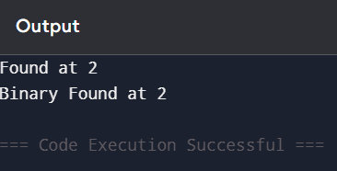

Q7: A library management system stores thousands of book records. Construct a concept map linking Data → Data Structure → Organization → Access Methods → Efficiency.
#include <stdio.h>

struct Book{
int id;
char name[20];
};

int main(){
struct Book b[2] = {{1,"C"},{2,"DS"}};
for(int i=0;i<2;i++)
printf("%d %s\n", b[i].id, b[i].name);
}
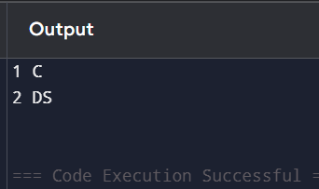
Q8: A ticket booking system supports booking, cancellation, and seat allocation. Construct a concept map connecting ADT → Operations → Implementation → Data Structures → Performance.
#include <stdio.h>

int main(){
int seats[5]={0};
seats[2]=1; // booked
printf("Seat 2 booked");
}
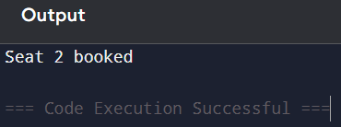

Q9: A company maintains hierarchical employee records. Construct a concept map connecting Tree → Nodes → Levels → Traversal → Searching → Efficiency.
#include <stdio.h>
#include <stdlib.h>

struct Node {
int data;
struct Node *left, *right;
};

// Function to create a new node
struct Node* createNode(int value) {
struct Node* newNode = (struct Node*)malloc(sizeof(struct Node));
newNode->data = value;
newNode->left = NULL;
newNode->right = NULL;
return newNode;
}

// Inorder Traversal
void inorder(struct Node *root) {
if (root != NULL) {
inorder(root->left);
printf("%d ", root->data);
inorder(root->right);
}
}

int main() {
// Creating a sample tree
struct Node* root = createNode(10);
root->left = createNode(5);
root->right = createNode(20);
root->left->left = createNode(3);
root->left->right = createNode(7);

printf("Inorder Traversal: ");
inorder(root);

return 0;
}

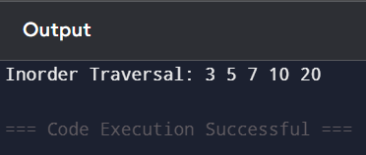

Q10: A printer system manages print jobs submitted by multiple users. Construct a concept map connecting Queue → FIFO → Job Scheduling → Processing → Efficiency and Stack → LIFO → Undo Operations.
#include <stdio.h>
#define MAX 5

int q[MAX], front = -1, rear = -1;

void enqueue(int x){
if(rear == MAX-1){
printf("Queue Overflow\n");
return;
}
if(front == -1) front = 0;
q[++rear] = x;
printf("Enqueued: %d\n", x);
}

void dequeue(){
if(front == -1 || front > rear){
printf("Queue Underflow\n");
return;
}
printf("Dequeued: %d\n", q[front]);
front++;
}

void display(){
if(front == -1 || front > rear){
printf("Queue is empty\n");
return;
}
printf("Queue elements: ");
for(int i = front; i <= rear; i++){
printf("%d ", q[i]);
}
printf("\n");
}

int main(){
enqueue(1);
enqueue(2);
dequeue();
display();
return 0;
}
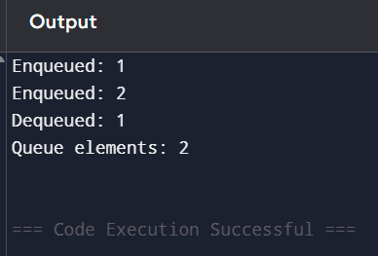

Q11: A student attendance system records daily presence data. Construct a concept map linking Array → Fixed Size → Sequential Access → Linked List → Dynamic Allocation → Flexibility.
#include <stdio.h>

int main(){
int arr[3]={1,2,3};
printf("%d", arr[1]);
}
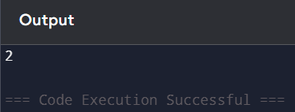

Q12: A delivery network connects multiple warehouses and delivery points. Construct a concept map connecting Graph → Nodes → Edges → Weighted Graph → Shortest Path → Efficiency.
#include <stdio.h>

int main(){
int graph[3][3]={{0,1,4},{1,0,2},{4,2,0}};
printf("Graph created");
}
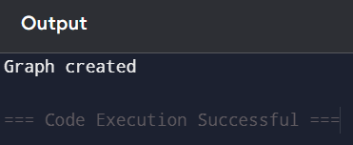

Q13: A digital archive stores millions of documents. Construct a concept map linking Searching → Linear Search → Binary Search → Sorted Data → Time Complexity → Performance.
#include <stdio.h>

int main(){
int a[]={1,2,3,4,5}, key=4;
int l=0,h=4,mid;
while(l<=h){
mid=(l+h)/2;
if(a[mid]==key) break;
else if(key>a[mid]) l=mid+1;
else h=mid-1;
}
printf("%d", mid);
}
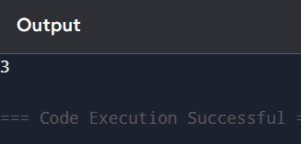

• Q14: A sorting system uses recursive algorithms. Construct a concept map linking Recursion → Divide and Conquer → Subproblems → Call Stack → Time Complexity → Efficiency.
#include <stdio.h>

void merge(int a[], int l, int m, int r){
int i = l, j = m + 1, k;
int temp[100]; // safer size

for(k = l; k <= r; k++){
if(i > m)
temp[k] = a[j++];
else if(j > r)
temp[k] = a[i++];
else if(a[i] < a[j])
temp[k] = a[i++];
else
temp[k] = a[j++];
}

for(k = l; k <= r; k++)
a[k] = temp[k];
}

void mergesort(int a[], int l, int r){
if(l < r){
int m = (l + r) / 2;
mergesort(a, l, m);
mergesort(a, m + 1, r);
merge(a, l, m, r);
}
}

int main(){
int a[5] = {5, 2, 8, 1, 3};
int n = 5;

mergesort(a, 0, n - 1);

printf("Sorted array: ");
for(int i = 0; i < n; i++){
printf("%d ", a[i]);
}

return 0;
}
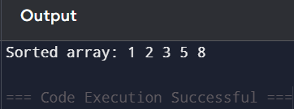

Q15: A retail system manages product inventory and sales records. Construct a concept map connecting Data Structure → Operations (Insert/Delete/Search/Update) → Time Complexity → Efficiency → Performance
#include <stdio.h>

int main(){
int a[5]={1,2,3,4,5}, key=3;
for(int i=0;i<5;i++){
if(a[i]==key) printf("Found");
}
}
